System Architecture of MCU & LRA actuator
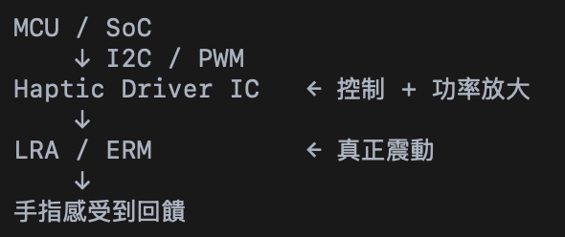
- MCU: EAP
  - use I2C signal to control the haptic driver
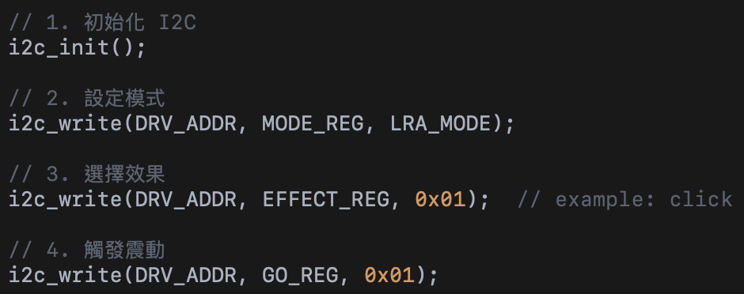
  - write C program
- Haptic driver(generate AC current for LRA): TI DRV2625
- LRA(Linear Resonant Actuator) Actuator: Precision Microdrives C10-100

I2C Architecture:
- Qwiic 怎麼連到 ESP board
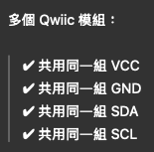
- 實際接線方式
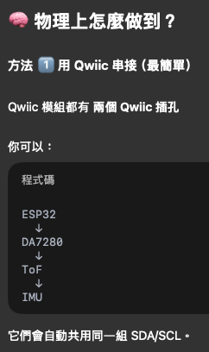
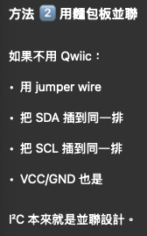
Haptic Driver + Actuator (Qwiic system)
- Haptic Driver: DialogSemi's DA7280 IC.
- LRA: G1040003D
- Stand alone mode
- Shopping website:
  - https://www.sparkfun.com/sparkfun-qwiic-haptic-driver-da7280.html
  - https://www.amazon.com/SparkFun-Qwiic-Haptic-Driver-Built/dp/B096YHK485
Actuator
- MicroDrives C10-100
  - Spec
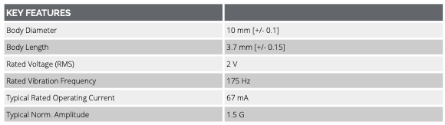
  - Shopping Website:
https://www.tindie.com/products/fyberlabs/precision-microdrives-10mm-vibration-motor/

Haptic Driver
- TI DRV2605L
  - https://www.ti.com/product/DRV2605L#description
  - Spec
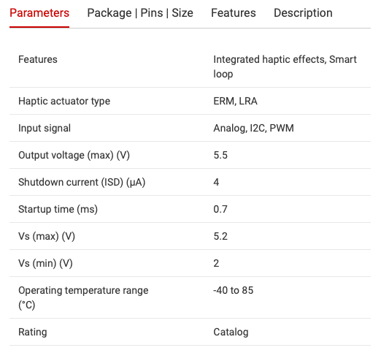
  - Shopping Website:
    - Haptic driver + actuator (ERM) https://www.adafruit.com/product/2305?srsltid=AfmBOoogruFbuGpl7TQgpWRsWs50jjdRKBwnwFGQ-ZCfSpss9bUiHY0F
    - https://www.sparkfun.com/sparkfun-haptic-motor-driver-drv2605l.html
- TI DRV2625
  - https://www.ti.com/product/DRV2625#params
  - Spec
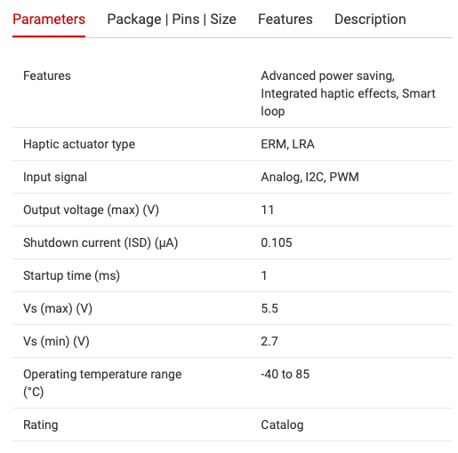
  - Shopping Website
https://www.digikey.com/en/products/detail/texas-instruments/DRV2625EVM-MINI/5870038?gclsrc=aw.ds&gad_source=1&gad_campaignid=17336967819&gbraid=0AAAAADrbLli8cCOutJgBz-vjw4g6zBzTS&gclid=CjwKCAiAncvMBhBEEiwA9GU_foUBlle7eT38zmgKEMjJWvIbSucMiTRw1QxOL4zE7Go3Z6OOC9mVshoCRhIQAvD_BwE

✅ USER STORIES

1. Forward Obstacle Awareness

As a visually impaired pedestrian,
I can receive directional haptic feedback when obstacles are detected ahead
so that I can adjust my path before collision.

Acceptance Criteria
- Detect obstacles within 0.5–3 meters
- Provide left/center/right vibration
- System latency < 200 ms

2. Suspended Hazard Detection

As a visually impaired user,
I can be alerted when head-level obstacles are detected
so that I avoid injury from elevated hazards.

Acceptance Criteria
- Distinguish ground-level vs. elevated obstacles
- Use distinct vibration pattern for head-level alerts

3. Low Cognitive Interaction

As a user navigating urban environments,
I can rely on vibration-only feedback
so that my hearing remains fully available for environmental sounds.

Acceptance Criteria
- No continuous audio output required
- Users can interpret signals after <30 minutes of training

4. All-Day Wearability

As a daily user,
I can wear the device comfortably for extended periods
so that it integrates naturally into my routine.

Acceptance Criteria
- Wristband weight < 80g
- Wireless operation
- Battery life ≥ 6 hours

5. Reliable Wireless Operation

As a user,
I can automatically connect the sensing module and wristband
so that the system works seamlessly without manual setup.

Acceptance Criteria
- Auto-pair within 5 seconds
- Alert user if connection fails

✅ USE CASES

Use Case 1 – Detecting a Forward Static Obstacle

Primary Actor: Visually impaired user
Goal: Avoid collision with obstacle

Preconditions
- Device is powered on
- Sensing module and wristband are connected
- User is walking forward

Main Flow (Events Exchanged)
- Sensing module continuously scans forward field of view.
- Obstacle detected at 1.5m slightly left.
- System computes spatial position.
- Directional command transmitted to wristband.
- Left-side vibration activated.
- User shifts slightly right.

Postconditions
- Obstacle avoided
- No physical contact occurs
- User remains in motion safely

Use Case 2 – Detecting Moving Pedestrian

Primary Actor: User

Preconditions
- System operational
- Dynamic object enters detection zone

Main Flow
- Moving object trajectory intersects user path.
- Risk threshold exceeded.
- Short rapid vibration triggered.
- User slows or pauses.

Postconditions
- Collision risk reduced
- User aware of dynamic hazard

Use Case 3 – Head-Level Hazard Alert

Primary Actor: User

Preconditions
- Elevated object within detection range

Main Flow
- Sensor detects obstacle above chest height.
- System classifies as head-level hazard.
- Unique double-pulse vibration pattern triggered.
- User lowers head or changes direction.

Postconditions
- Head injury avoided
- Hazard successfully communicated

Use Case 4 – No Obstacle Present

Primary Actor: User

Preconditions
- Clear walking path

Main Flow
- Sensor scans environment.
- No obstacles detected.
- No vibration triggered.

Postconditions
- User walks naturally
- System remains passive
- No unnecessary cognitive load

Use Case 5 – Low Battery Warning

Primary Actor: User

Preconditions
- Battery < 15%

Main Flow
- Power management module detects low battery.
- Special vibration pattern sent to wristband.
- User acknowledges and plans recharge.

Postconditions
- User informed of power state
- Safe shutdown possible

Functional Requirements Covered
- Real-time obstacle detection
- Directional haptic mapping
- Height classification
- Dynamic object detection
- Wireless communication
- Power monitoring

Non-Functional Requirements Covered
- Low latency (<200ms)
- Low cognitive load
- Wearable comfort
- Energy efficiency
- Reliability and fail-safe alerts

